Assignment Solution

NOTE: Do not forget to see manual page using "--help" option in command when searching for options/commands for a particular task.

1. Install Docker, either on your native OS or on a VM. Make sure it runs. Type "docker -v" to check if it's installed.

If you can't install or configure Docker, you can use the online docker setup to do the assignment.
Step1 Goto:- https://www.katacoda.com/courses/kubernetes/playground
Step2 Click on "continue" button on the left panel
Step3 Click on "launch.sh" button on the left panel
Step4 From the right panel use the top console to execute below command:-
docker -v

Try below commands for help
docker --help ---> This command shows all available options and commands to work with images and containers
docker image --help ---> This command shows all the avaialble options and commands to work with docker images
docker container --help ---> This command shows all the avaialble options and commands to work with docker containers

NOTE:- DO NOT TRY TO USE INTERNET TO SOLVE ASSIGNMENT, BETTER USE THE ABOVE --help OPTION TO SEE THE MANUAL OF ANY PARTICULAR COMMAND AND FIGURE OUT THE SOLUTIONS ON YOUR OWN.
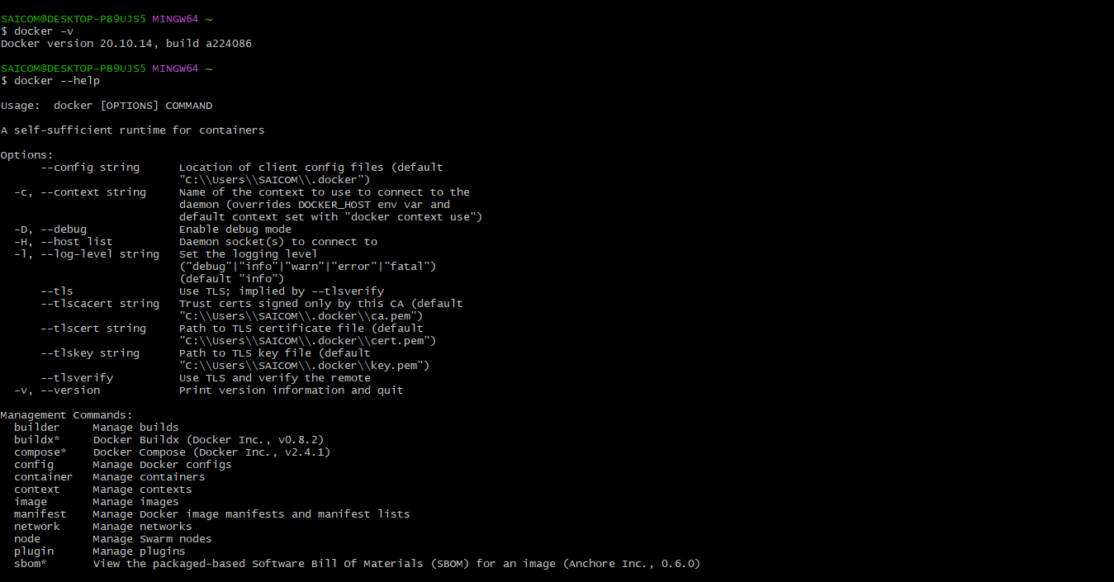
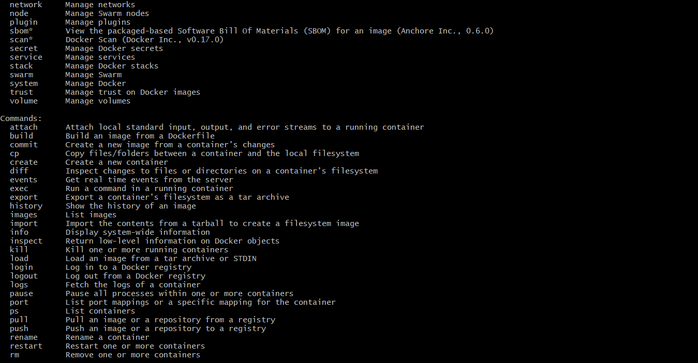
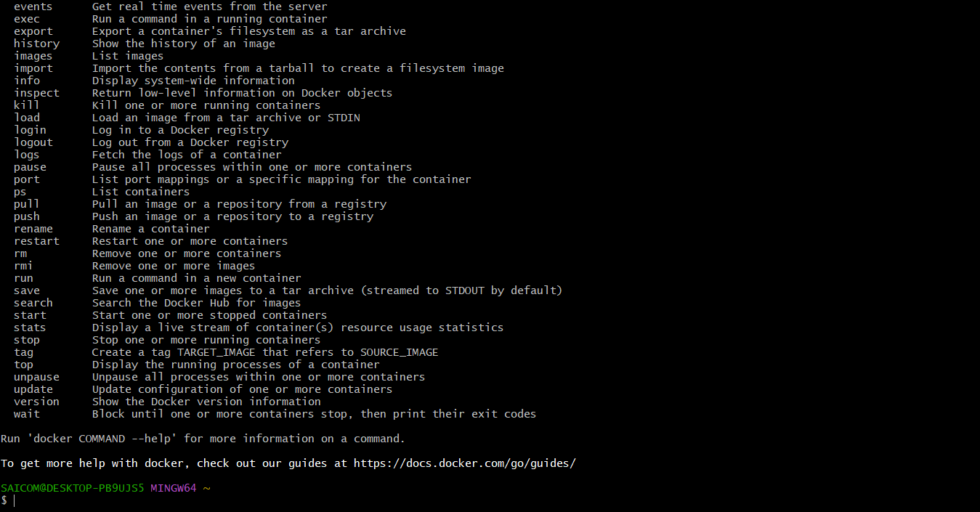
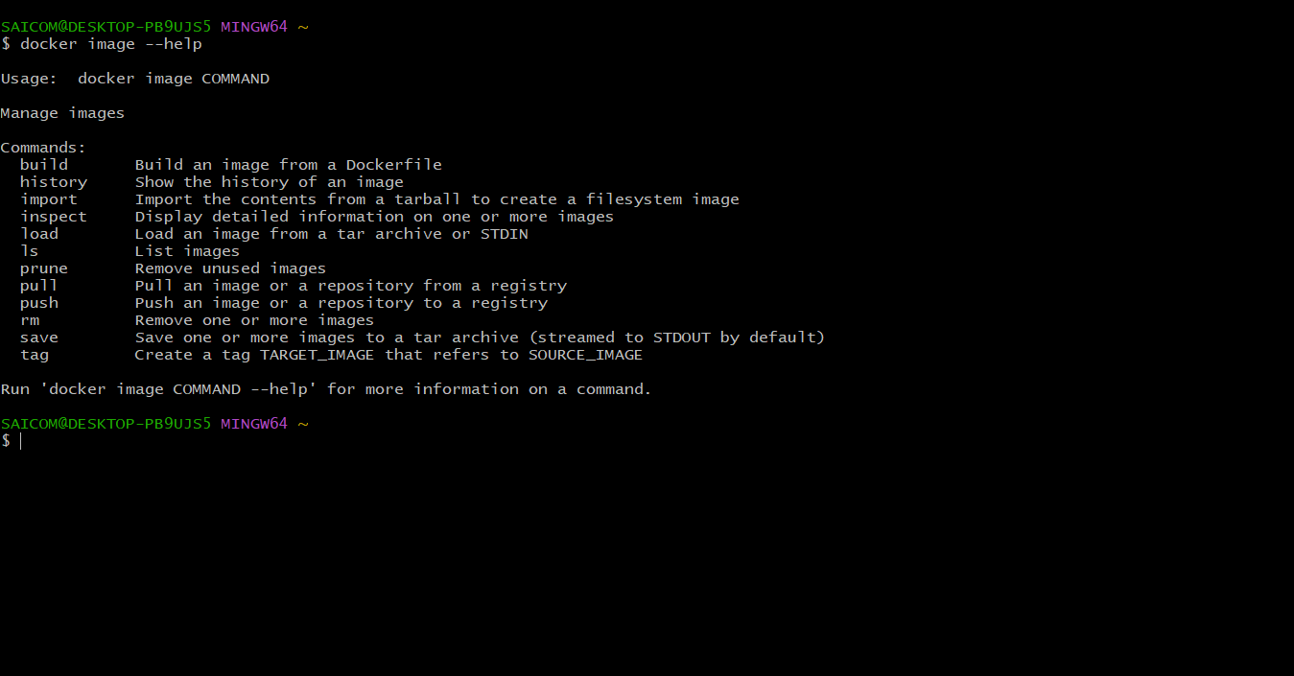
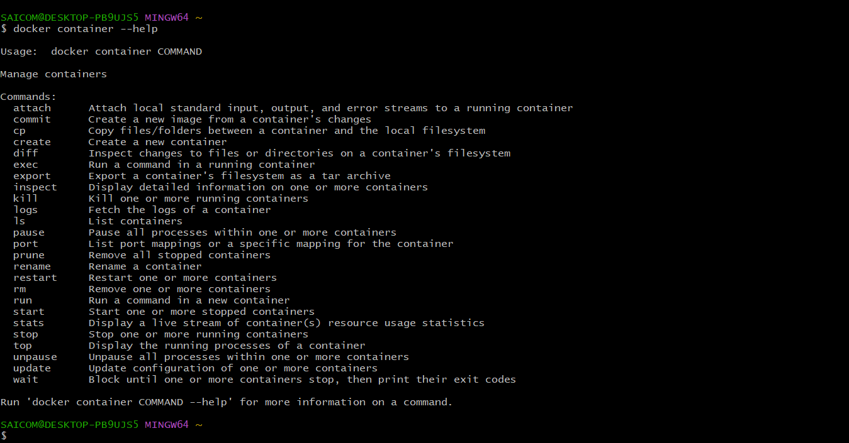

2. Find a image from dockerhub of your choice(recommeded: nginx), don't use browser, pull the official image from dockerhub
docker pull nginx
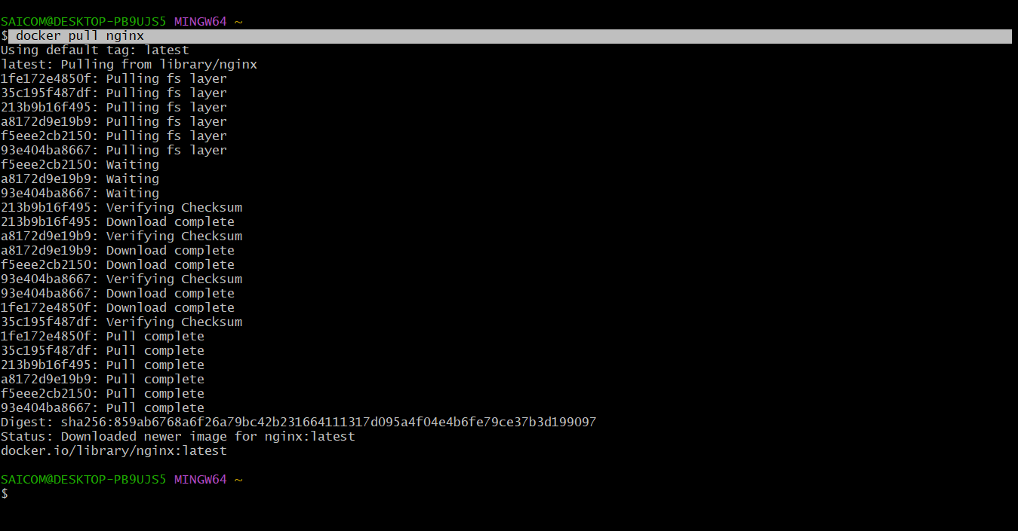

3. List all the available images in your machine/vm, make sure you see recently pulled image in the list.
docker images
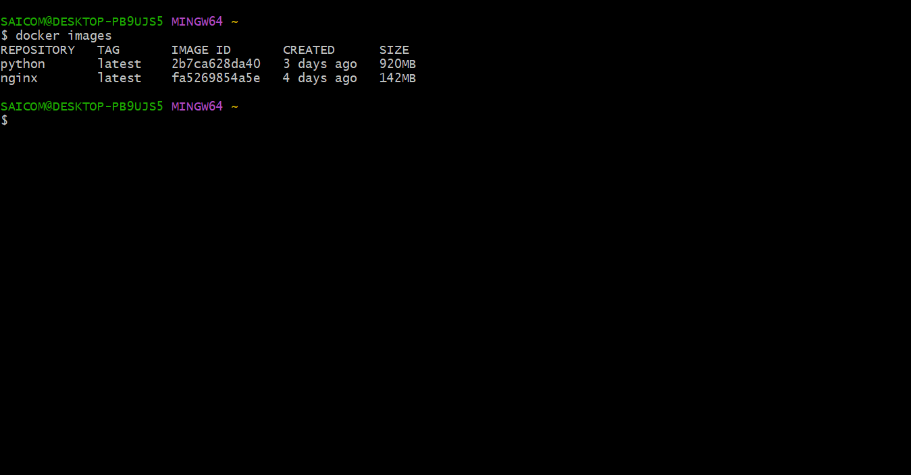

4. Find out the "Full" ImageId of the image that you pulled and write it below.
docker images -q
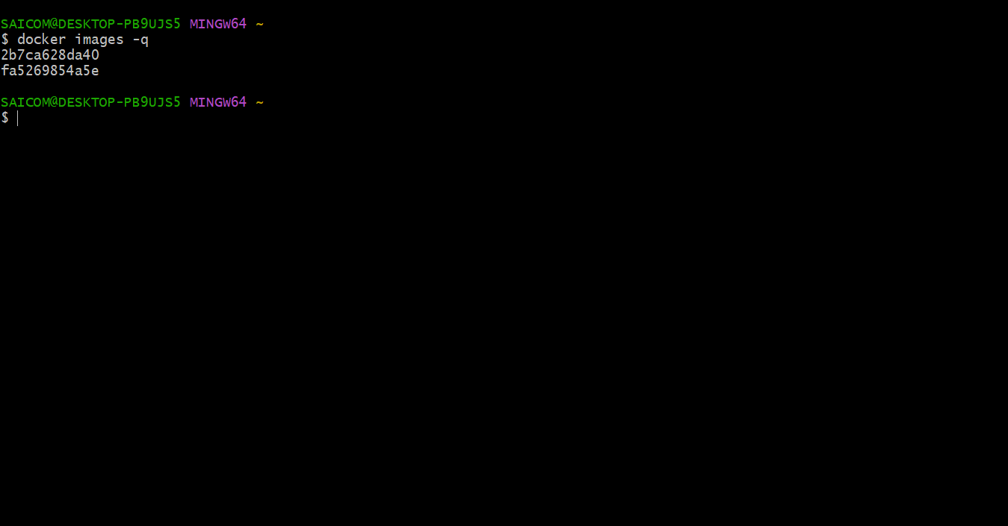

5. Create a container of your image
docker container create hello-world
6. List all the running containers
docker ps
7. List all the running and stopped containers
docker ps -a
8. Find out the "Full" containerId of the container and write it below.
docker ps -aqf "name=containername"
9. Find out how many image layers are used to build this image.
docker image inspect nginx
10. Get the Apache Tomcat 7 server image from the docker hub.
docker pull tomcat:7

11. Run the Apache Tomcat 7, I mean create a container of Apache Tomcat.
docker run tomcat:7
12. Find out what is the IP Address of the Apache Tomcat Container that it is running on
docker inspect <containername or id>
13. Which Port it is using?
docker port tomcat
14. Try to access the Tomcat's home page from your machine/vm.
docker run --name tomcat -P bitnami/tomcat:latest
15. What is the disk size of Apache Tomcat image?
docker images
16. Find out list of all environment variables that is configured for tomcat image, can you see JAVA_HOME and CATALINA_HOME? What did you notice about it?
docker exec container_id printenv
Yes I can see the variables
CATALINA_HOME specifies the location of the root directory of the binary distribution of Tomcat
CATALINA_HOME=/usr/local/tomcat
JAVA_HOME used to specify the location of a Java Runtime Environment that is used to start the environment.
JAVA_HOME=/usr/local/openjdk-11
17. Find out which port is exposed for tomcat?
docker inspect tomcat
18. Run multiple conntainers of tomcat on different port and access it's home page.
TOMCAT_VERSION=10.0.20
19. Pull ubuntu os from dockerhub, try to pull 2 images of ubuntu, Except the latest one.
docker pull ubuntu:16.04
docker pull ubuntu:18.04
20. Run the container of ubuntu in attached mode.
docker run -it --name ubuntu-16 ubuntu:16.04
docker start ubuntu-16
docker attach ubuntu-16
21. Run the container of another ubuntu in detached mode.
docker run -d --name ubuntu2 ubuntu:18.04
22. Check how many ubuntu containers are running and stopped
docker ps -a
23. Is the tomcat container running? If no, start one.
Yes it is running
24. Check the logs, generated by tomcat container(don't forget to make request to tomcat's home page to see the log).
docker logs container_id_of_tomcat
25. Check if ubuntu conatiner is running? If no, start one in attached mode to the terminal.
docker attach ubuntu_container_id
26. Login as root user in ubuntu container
docker exec -it ubuntu2 bash
27. Create a file with any name in root directory
touch file1
28. Install software of your choice in ubuntu container using "apt-get install"
apt-get update
apt-get install python3
29. Now exit the ubuntu shell, are you back to your host machine, if not, come back to the host machine.
exit
30. Check if the ubuntu container is running.
NO
docker ps
31. Create a new ubuntu container out of the same image as that previous container in attached mode.
docker run -it --name ubuntu-new ubuntu:16.04
docker start ubuntu-new
docker attach ubuntu-new
32. Login as a root user
It is already in root user after running the above commands
33. Check if you can see the file created in previous container, you will not see the file as well as software that you installed in the previous container. Now kill this Container.
docker kill container-id
34. Do you have the previous ubuntu container where you created the file and installed the software? If no reapeat step 25 to 29.
yes
35. Create an Image out of the existing container.
docker commit ubuntu-new SAICOM/user_image
36. Now Create a Container out of this image and login into it to see if you can see the file and software installed by you in the previous container.
NO
37. Do you have running tomcat container? If yes, Stop it and kill all tomcat container.
docker kill tomcat_container_id
38. Create an index.html file with following code in it:-
<h1>This is Tomcat Container</h1>
Now, Start a tomcat container in such a way that on hitting its URL for home page it should show the above html page.
nano index.html
write the above content in index.html exit the nano
Dockerfile should contain
ADD index.html in /usr/local/tomcat/webapps/
docker run -it --name c1 -p 8080:8080 tomcat
39. type below command:-
docker images --help
Now, try to run command that proves the concept of following three options:-
1. -a
2. -f
3. -q

write atleast 1 command using each option above and prove their concepts as described in the --help.
docker images -a --------- shows all images
docker images -f ---------- filter the output based on condition
docker images -q ----------Display only the image id

40. type below command:-
docker ps --help
Now, try to run command that proves the concept of following six options:-
1. -a
2. -f
3. -q
4. -n
5. -l
6. -s
docker ps -a ----------shows all the running and stopped containers
docker ps -f ----------used to filter the result based on condition
docker ps -q---------used to show only container IDs
docker ps -n ----------used to show last n created containers(includes all states)
docker ps -l ----------shows the latest created containers
docker ps -s ----------Display total file sizes

